Walkthrough to build an Arduino Fencing Scoring Machine/Tester.

Check
https://github.com/pietwauters/esp32-scoring-device

https://github.com/pietwauters/esp32_scoring_device_hardware

https://github.com/pietwauters/remotecontrolapp

https://github.com/pietwauters/WeaponWireTester

For mopre info

Part list.

https://github.com/pietwauters/esp32_scoring_device_hardware/blob/main/BOM.md

Note
All items marked with * are optional. JST or header connectors can be substituted by soldering the wires directly to the board or ESP.

Tip
JST- XH 2.54mm are the recommended connector type for the connectors because they are keyed and you can't connect them the wrong way (SEEMS AS IT IS NOT TRUE FOR J2 POWER CONNECTORS). Simple header pins work fine too, but make sure to orient the plug correctly. JSTs can be bought as kit with wire and crimper. Connectors are preferred over soldering directly to the board for serviceability.

Tip
Buy pin strip, socket (female) 1 x 15 2,54mm pitch wide enough to accomodate the ESP32 board

3 weapon scoring device
Number of pieces | Designator | Description | Value | Size | Remarks
1* |  | PCB | Rev 1.2b |  | alternatively you could build the circuit on a breadboard or perfboard
1 | U1 | ESP32 DevKit V1 |  |  | be sure to get the 30 pin version (2 x 15). There are many board flavors out there e.g. V4 is 38 pin
2 |  | 64 LED matrix panel | WS2812B-64 led matrix | 65mm x 65mm
1* |  | MAX7219 Dot matrix Module 4-in-1 LED Display module
2 | C1,C3 | radial electrolytic capacitor | 470µF - 35V | Ø10mm - 5mm pitch
2 | C2,C4 | polyester film capacitor | 0,1µF | L7,3 x W2,5mm
2 | Q1,Q2 | BC337 NPN transistor | 0,8A 45V | TO-92
5 | R1,R2,R3,R4,R5 | metal film resistor | 470Ω 1%  47Ω 1% for tester | 1/4W
2 | R6,R7 | metal film resistor | 33Ω 1%  47Ω 1% for tester | 1/4W
1 | R8 | metal film resistor | 3,3kΩ 1% | 1/4W
1 | R9 | metal film resistor | 2,2kΩ 1% | 1/4W
1 | R10 | metal film resistor | 150Ω 1% | 1/4W
1* | R11 | metal film resistor | 0Ω bridge | 1/4W | can be substituted by a simple wire bridge
7 |  | female banana jack |  | 4mm, panel mount
1 | R12 | metal film resistor | 10kΩ 1% | 1/4W
1* | J1 | JST connector | 1 x 7 | 2,54mm pitch
1* | J2 | JST connector | 1 x 3 | 2,54mm pitch
1* | J3 | JST connector | 1 x 5 | 2,54mm pitch
2* | J8,J9 | JST connector | 1 x 2 | 2,54mm pitch | populate as required
2* |  | pin strip, socket (female) | 1 x 15 | 2,54mm pitch | header for the ESP32 board
1* | Q3 | power mosfet | FQP27P06 | TO-220 | reverse voltage protection, strongly recommended if you power externally via J9
1* | J4 | Right angle 2,54mm socket |  | 6-pin | for plug-in connection of a HC-06 BT module

Weapons / body wire tester
Number of pieces | Designator | Description | Value | Size | Remarks
1* |  | PCB | Rev 1.2b |  | alternatively you could build the circuit on a breadboard or perfboard
1 | U1 | ESP32 DevKit V1 |  |  | be sure to get the 30 pin version (2 x 15). There are many board flavors out there e.g. V4 is 38 pin
1 |  | 25 LED matrix panel | WS2812B-25 led matrix | 38mm x 38mm
2 | C1,C3 | radial electrolytic capacitor | 470µF - 35V | Ø10mm - 5mm pitch
2 | C2,C4 | polyester film capacitor | 0,1µF | L7,3 x W2,5mm
5 | R1,R2,R3,R4,R5 | metal film resistor | 47Ω 1% | 1/4W | These resistors are marked 470Ω* on the silkscreen
2 | R6,R7 | metal film resistor | 33Ω 1% | 1/4W
7 |  | female banana jack |  | 4mm, panel mount
1* | J1 | JST connector | 1 x 7 | 2,54mm pitch
1* | J2 | JST connector | 1 x 3 | 2,54mm pitch

For the JST connectors, I recommend to buy fully assembled versions like: https://nl.aliexpress.com/item/1005002396070880.html?spm=a2g0o.order_list.order_list_main.174.774879d2y4pA41&gatewayAdapt=glo2nld
You will need different versions: 7 pins, 5 pins, 3 pins, 2 pins.

Screws to fix parts: M3 x25mm to close the box. M2x8mm to fix the pcb M3 x6mm for everything else
https://nl.aliexpress.com/item/32810872544.html

Brass insets 2, 3 and 6 mm (OD 8 mm Lenght 6 mm)
https://es.aliexpress.com/item/1005006472702418.html?spm=a2g0o.order_detail.order_detail_item.3.28aa6d76LhVdHD&gatewayAdapt=glo2nld
https://es.aliexpress.com/item/1005008666672949.html

USB-C feeding connection
https://nl.aliexpress.com/item/1005007463286632.html

WS2812 go for:
https://es.aliexpress.com/item/1005005697976566.html

ESP32 DevKit V1
https://es.aliexpress.com/item/1005008275465796.html

MAX7219 Dot matrix Module 4-in-1 LED Display module
https://es.aliexpress.com/item/1005005855156717.html

WS2812 para el probador:
https://es.aliexpress.com/item/4001251900516.html

4 mm sockets for the connector
https://www.aliexpress.com/item/1005006499956025.html?spm=a2g0o.order_list.order_list_main.139.6ec518021tWRP7

15 pins socket
https://es.aliexpress.com/item/4001198421663.html?spm=a2g0o.order_list.order_list_main.178.1ab079d2q3llHs&gatewayAdapt=glo2nld

Zumbadores
https://es.aliexpress.com/item/1005006271216453.html

Print the box using a 3D printer.

Print the enclosure for the device using the files in the directory STL or download from:

Scoring device:

https://www.printables.com/model/1138815-enclosure-for-scoring-device
The front part is a multi-color part: black for the box and transparent for the “windows”.
Add the 4 files together in your slicer to treat them as multiple parts of the same object:
ScoringBoxV3_0.3-TransparentWS2812Left.stl
ScoringBoxV3_0.3-TransparentWS2812Right.stl
ScoringBoxV3_0.3-Transparentleddisplay.stl
ScoringBoxV3_0.6-Front.stl
Testing Box:
YAPP_WireTester_v3.2.stl (There is a new versión for the upper part)
You will need a thread cutter for the banana connctors. I print thread, but it is easier if you cut them with a tool. It is M6, with a fine pitch 0.75. (not standard pitch) https://es.aliexpress.com/item/1005005815200788.html?spm=a2g0o.order_list.order_list_main.177.15a7194dSKyKJ3&gatewayAdapt=glo2esp

Other interesting printables are:
https://www.printables.com/model/864187-body-cord-assembly-help
https://www.printables.com/model/1117413-foil-guard-socket-improvement
https://www.printables.com/model/1145428-foil-tip-assembly-help

You will need a thread cutter for the banana connctors. I print thread, but it is easier if you cut them with a tool. It is M6, with a fine pitch 0.75. (not standard pitch) https://es.aliexpress.com/item/1005005815200788.html

Remote control app: https://drive.google.com/file/d/1Urqx_oneAUGP4X9xaYgV_Lu_l0lxvPS3/view?usp=drive_link
Firmware: https://drive.google.com/file/d/1NzSybVZvEsW4hmOQh3sam8iV9_sMTCQC/view?usp=drive_link
First time programming: https://drive.google.com/file/d/1-c_6lXHVxWl4rX92xM3lpi4dTMm7Uuvw/view?usp=sharing
First time programming tool: https://espressif.github.io/esp-launchpad/

1.- Mount the board as described, with 470 Ohm resistances for R1 to R5 and 33 Ohm for R6 ad R7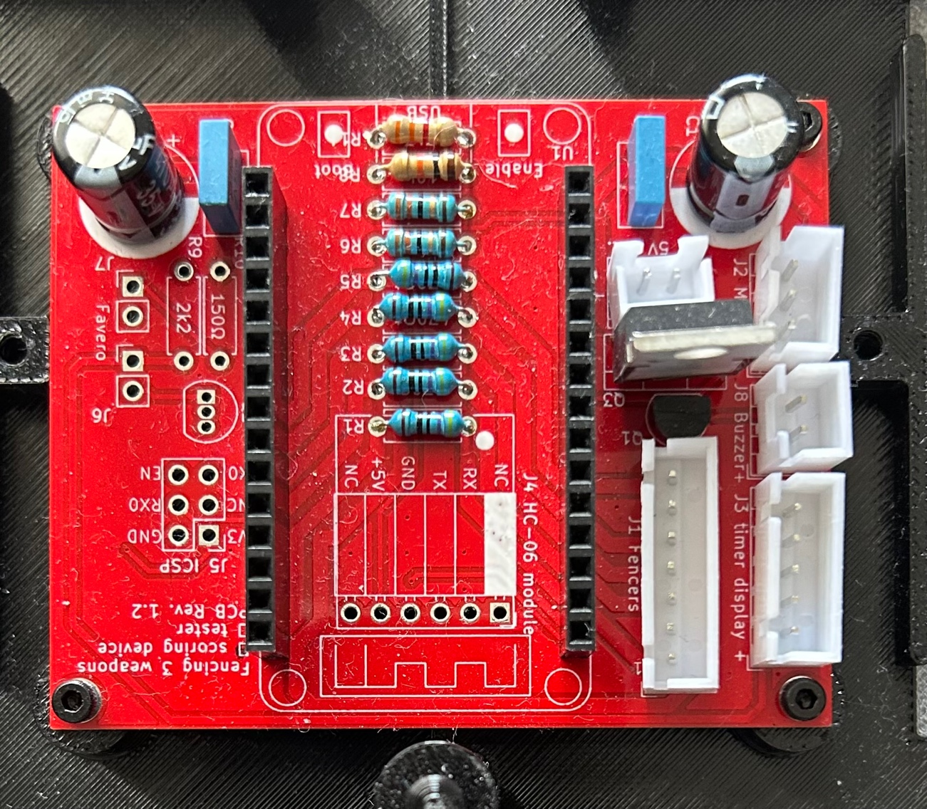
There is space enough for the board so it is better to use a socket.

Mount it with the USB port facing the buzzer hole, so you can install the buzzer at the end. 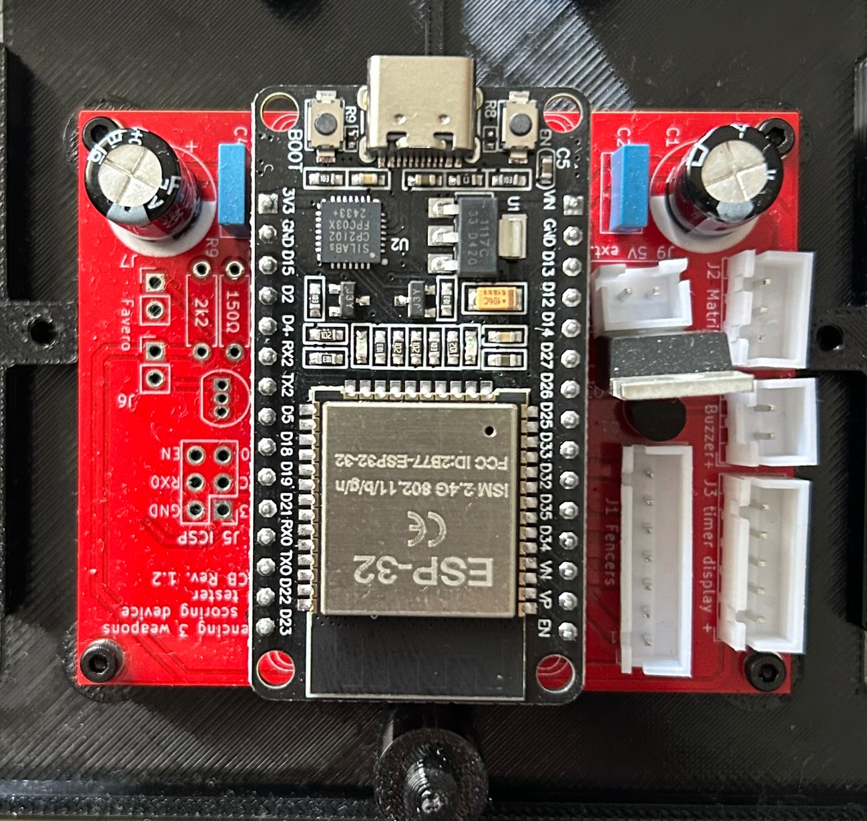

2- Connect the LED board with the pins facing right
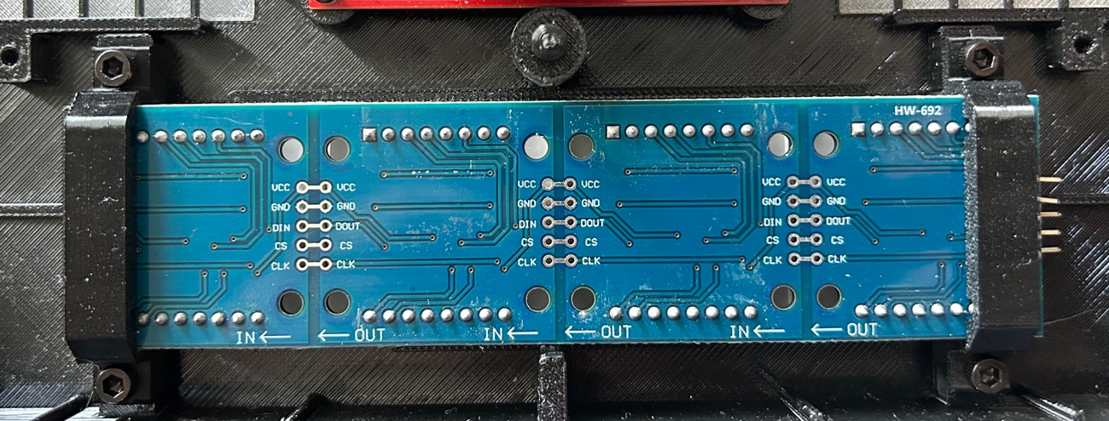

J5 Connections to the LED BOARD
5 Orange to CLK
4 Yellow to CS
3 White to DIN
2 Red to GND
1 Black to VCC

Pictures of the connections
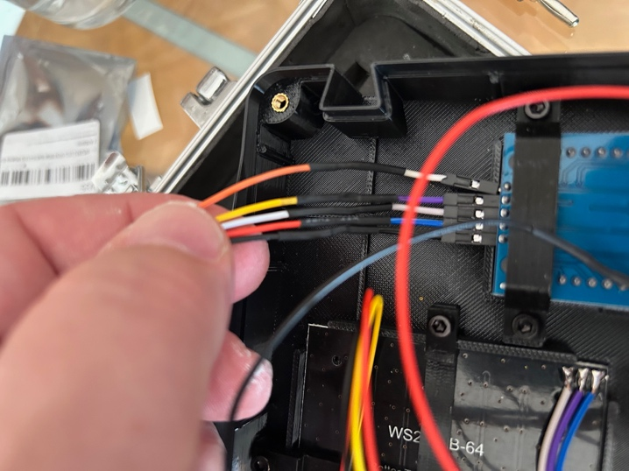

J3 Connections to the LED Boards
1 Yellow V+
2 Black IN
3 Red V-
Mount both boards upside-down and connect them
V+ top V+
Out to In
V- to V-
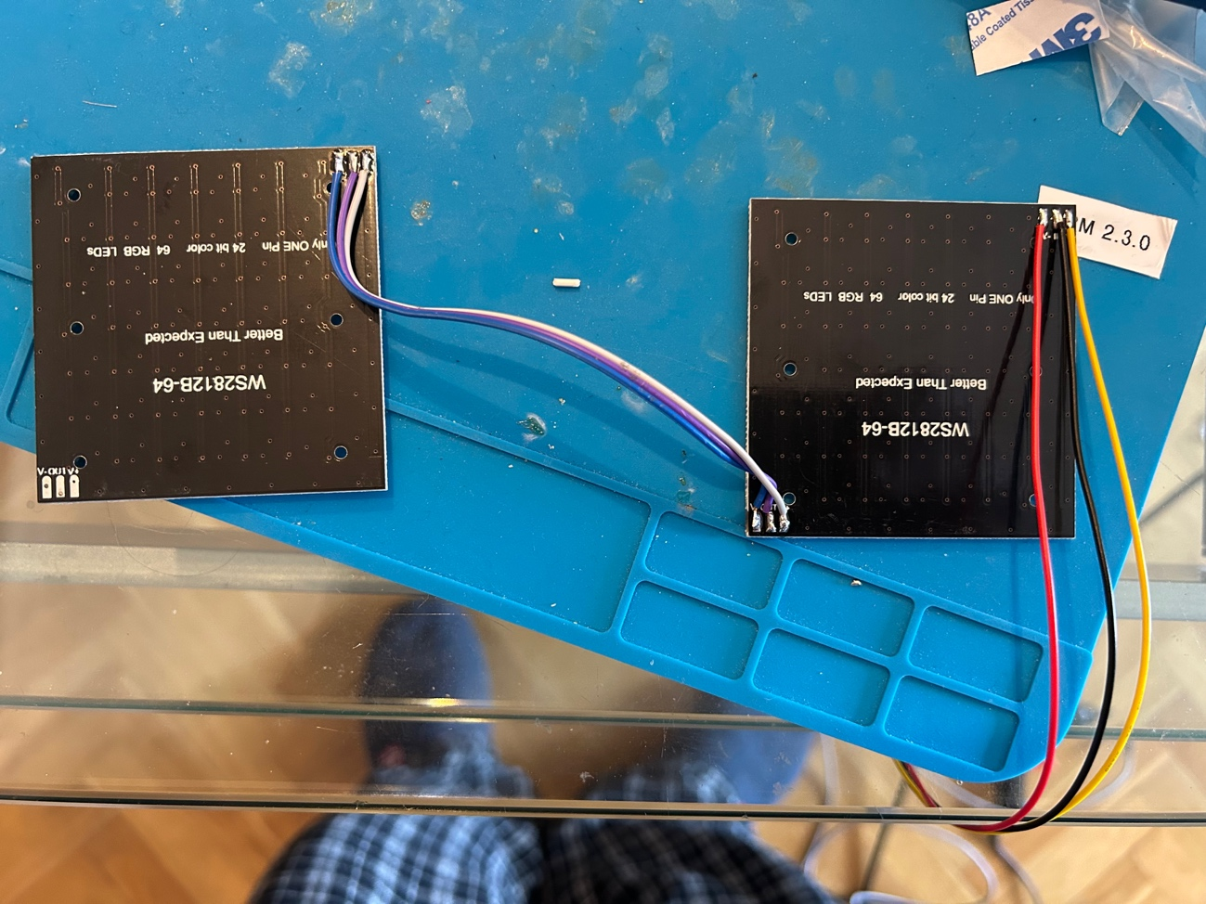
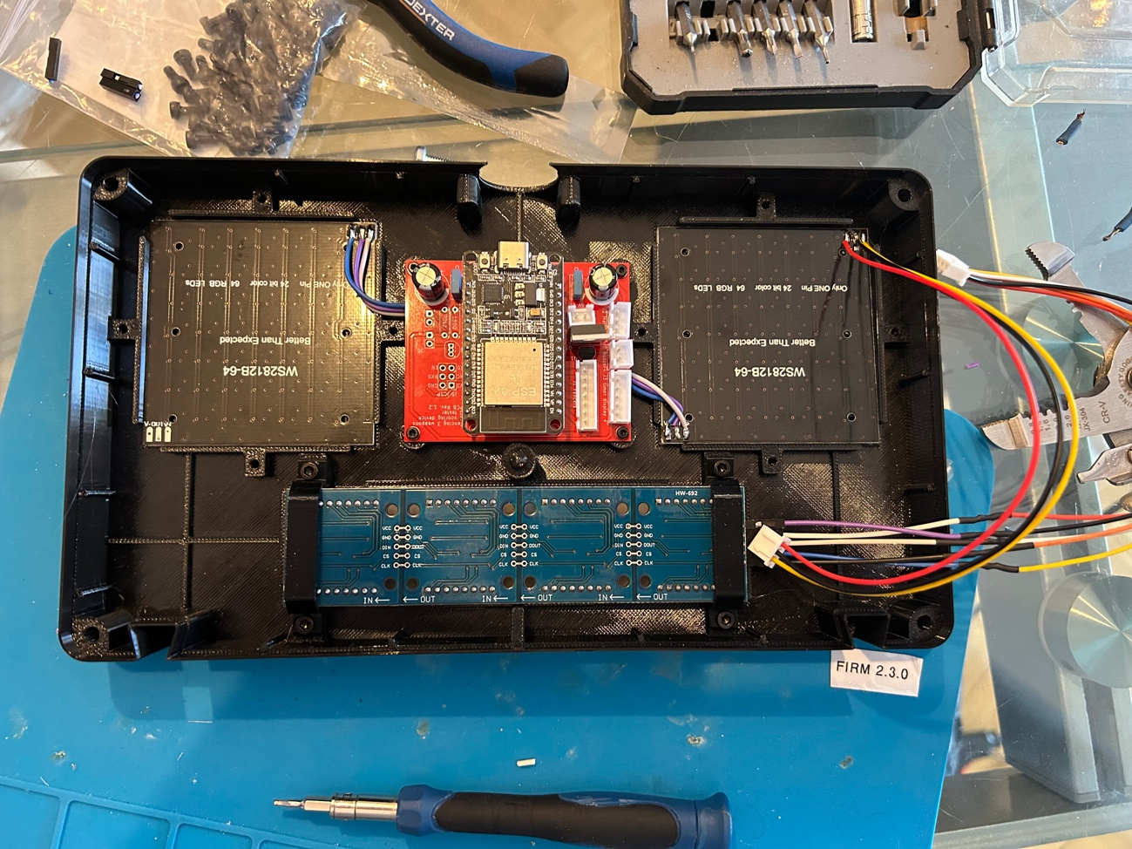

J7 connectors to the fencers:
From left to right
1 Black
2 Red
3 White
4 Yellow
5 Blue
6 Green
7 Orange

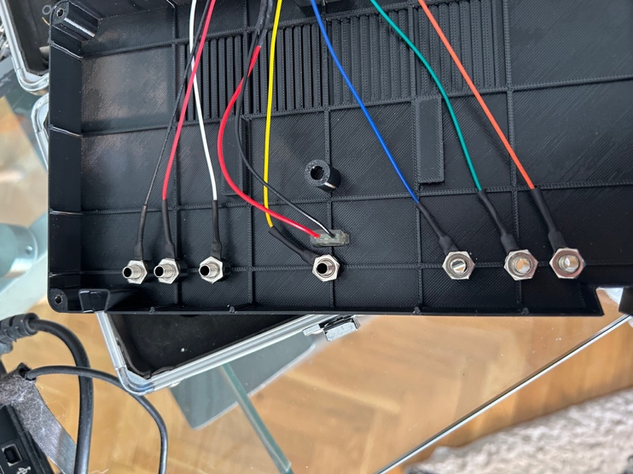

Install the USB-C connector taking care that the red wire (+) is connected LEFT as seen as from the USB of the ESP Board. Some J2 connectors are reversed, check before installing the socket for power and buzzer.

Select an Smart USB-C connector so you can use any USB-C source and not only 5 V ones.

Connect the board to a computer using the USB port. Get sure that you have the right drivers installed as there are two flavours of ESP ports.

CP2102

